
UNIVERSITY OF IBADAN
FACULTY OF COMPUTING
DEPARTMENT OF COMPUTER SCIENCE

COURSE: DATA ENGINEERING (CSC 796)
TERM PAPER TOPIC:
EMERGING TRENDS IN DATA ENGINEERING: AI-ASSISTED ENGINEERING AND DATA PIPELINES FOR RETRIEVAL-AUGMENTED GENERATION, WITH A CASE STUDY IN HUMAN-AI NEWS CONTENT PROVENANCE AND RETRIEVAL
BY
AYANTUNMBI RAPHAEL AYANTAYO
260263
rayantunmbi260263@stu.ui.edu.ng
Lecturer-in-charge: Dr B.I. Ayinla
A Term Paper Submitted in Partial Fulfilment of the Requirements for the Data Engineering Course
September, 2026.

TABLE OF CONTENTS

LIST OF TABLES ……………………………………………………………….…………………... iv
LIST OF FIGURES ……………………………………………………………………….………….. v
ABSTRACT vi
INTRODUCTION 1
1.1 Background 1
1.2 Problem Statement 1
1.3 Objectives 2
1.4 Scope and Case Study 2
1.5 Structure of the Paper 2
LITERATURE REVIEW 3
2.1 BACKGROUND AND CONCEPTUAL OVERVIEW 3
2.1.1 Data Engineering: Core Concepts 3
2.1.2 Large Language Models 3
2.1.3 Retrieval-Augmented Generation 3
2.1.4 Data Provenance and the Model Collapse Problem 4
2.2 EMERGING TRENDS IN DATA ENGINEERING 4
2.2.1 The Lakehouse and Open Table Formats 4
2.2.2 Data Observability and Governance-as-Code 4
2.2.3 Real-Time and Streaming Convergence 5
2.2.4 The Convergence of Data Engineering, AI Engineering, and Content Provenance 5
2.3. AI-ASSISTED DATA ENGINEERING 5
2.3.1 LLMs for Code Generation in Data Engineering 5
2.3.2 LLM-Assisted Documentation 6
2.3.3 LLM-Assisted Code Optimisation 6
2.3.4 Risks and the Need for Human Oversight 6
2.4. DATA ENGINEERING FOR LLMs: BUILDING PIPELINES FOR RETRIEVAL-AUGMENTED GENERATION 6
2.4.1 Why RAG Needs Its Own Data Pipeline 6
2.4.2 Ingestion and Cleaning for RAG 7
2.4.3 Chunking Strategies 7
2.4.4 Embedding and Vector Storage 7
2.4.5 Retrieval and Orchestration 7
2.4.6 Provenance-Aware Ingestion 8
2.5. HANDS-ON PROJECT AND REAL-WORLD CASE STUDY 8
2.5.1 The Real-World Problem 8
2.5.2 Why Data Engineering Is Central to This Problem 8
2.5.3 Scope of the Practical Demonstration 9
SYSTEM ANALYSIS AND DESIGN 10
3.1. DATASET DESCRIPTION AND PREPARATION 10
3.1.1 Dataset Name and Source 10
3.1.2 Why This Dataset Was Selected 10
3.1.3 Dataset Structure and Key Fields 10
3.1.4 Data Quality Issues Identified 11
3.1.5 Cleaning and Preprocessing Performed 11
3.1.6 Limitations of the Dataset 12
3.2. METHODOLOGY 13
3.2.1 Overall Approach 13
3.2.2 Tools and Technologies, and Justification for Each 13
3.2.3 Justification for the TF-IDF Substitution and Its Boundaries 13
3.2.4 Methodology for the Provenance Analysis 14
3.2.5 Evaluation Approach 14
3.3. SYSTEM AND DATA PIPELINE DESIGN 14
3.3.1 Architecture Overview 14
3.3.2 Conceptual Data Model 15
3.3.3 Pipeline Orchestration Considerations 16
3.4. IMPLEMENTATION 16
3.4.1 Stage 1: Ingestion and Profiling 16
3.4.2 Stage 2: Cleaning, Topic Normalisation, and Validation 17
3.4.3 Stage 3: Provenance and Content-Quality Analysis 17
3.4.4 Interpreting the Provenance Analysis Before Seeing the Results 18
3.4.5 Stage 4: Chunking, Vector Storage, and Retrieval 18
SYSTEM IMPLEMENTATION AND PRESENTATION OF RESULTS 19
4.1. RESULTS 19
4.1.1 Ingestion and Profiling Results 19
4.1.2 Cleaning and Validation Results 19
4.1.3 Chunking Results 20
4.1.4 Provenance and Content-Quality Analysis Results 20
4.1.5 Retrieval Evaluation Results 21
4.1.6 Pipeline Performance 22
4.2. DISCUSSIONS OF RESULT 22
4.2.1 Interpreting the Retrieval Results 22
4.2.2 What the Data Quality Findings Show 23
4.2.3 What the Provenance Analysis Shows 23
4.2.4 Pipeline Performance and Scalability 23
4.2.5 The Role of AI Assistance in This Workflow 23
4.2.6 Practical Implications for a Provenance-Aware Newsroom Deployment 24
SUMMARY, RECOMMENDATIONS AND CONCLUSION 25
5.1 Strengths and Weaknesses Summary 25
5.2. CHALLENGES AND LIMITATIONS 25
5.2.1 Environment Constraints 25
5.2.2 Dataset Limitations 25
5.2.3 Evaluation Limitations 25
5.2.4 Governance and Ethical Considerations 26
5.3 FUTURE WORK 26
5.4 CONCLUSION 26
REFERENCES 27

LIST OF TABLES
Table Page
3.1 Dataset Description 10
4.1 Raw Dataset Profile 19
4.2 Cleaning Summary 19
4.3 Final Category Distribution (Cleaned Dataset) 20
4.4 Data Validation Suite Results (Post-Cleaning) 20
4.5 Chunking and Vector Store Statistics 20
4.6 Human vs AI-Generated Text Statistcs 21
4.7 Heuristic Provenance Classifier Evaluation 21
4.8 Retrieval Evaluation on Six Representative Queries 21
4.9 Indexing and Query Latency 22

LIST OF FIGURES
Figure Page
3.1 Terminal output of the data cleaning script showing row counts before and after
deduplication, and the topic-field normalisation mapping 12
3.2 RAG Data Pipeline Architecture with Provenance Screening 14
3.3 RAG Data Pipeline Architecture with Provenance Screening 15
3.4 Conceptual Data Model (Entity-Relationship Diagram) 16
3.5 Terminal output showing the JSON profiling report for the raw dataset 17
3.6 Terminal output showing the validation suite results, all seven checks passing 17
3.7 Output showing the human-vs-AI comparison statistics and heuristic
classifier evaluation 18
3.8 Output of a retrieval query with the top five returned chunks and their
similarity scores 18

ABSTRACT
The field of data engineering is changing fast, with large language models (LLMs) on the consumer side and the engineer increasingly on the creation side of the data. One side of this is that LLMs are becoming more and more essential to helping data engineers generate, document and optimise code. Conversely, applications based on LLM, especially Retrieval-Augmented Generation (RAG) systems require meticulously designed data pipelines to import, clean, validate, slice and dice text, embed it, and index it for later retrieval and grounding during inference time. The term paper explores these three trends in the context of today's state of data engineering, along with the lakehouse architecture, open table formats, and data observability. A practical case study is built around creating a data pipeline for a RAG-based news research assistant, which includes content provenance validation before ingestion, leveraging a 3,000 real news article dataset (HANA dataset (Human And AI-authored News Articles)) with equal number of articles written by AI models (GPT-3.5) and by humans. A practical case study is developed on building a data pipeline for a RAG-based news research assistant that also validates the content provenance before ingesting it into the RAG, using the HANA dataset (Human And AI-authored News Articles), a peer-reviewed 2024 dataset comprising of 3,000 real news articles from nine reputable sources, each accompanied by an article generated by AI models (GPT-3.5). The entire data engineering chain has been implemented to have all the above features. Profiling revealed that the word-count field reported by the dataset undercounted the actual length of an article by an average of 18.4 words and that 45 articles were duplicate entries after the data was cleaned, yielding 20,414 chunks for retrieval. The human-versus-AI comparison shows that, on average, the GPT-3.5 rephraser reduced the length of articles from 658 to 515 words, and increased lexical diversity (type-token ratio from 0.496 to 0.558), and that a no frills surface-level heuristic, based on these differences, correctly classified only 64% of a blind test (with a recall of only 0.40 for AI-generated content), showing that naive statistical heuristics are not sufficient for reliable content-provenance screening. Better performances were found in a top-1 accuracy of 50% and a mean precision at 5 of 0.667 in a retrieval evaluation, where the six queries were distributed among the various topic categories of the dataset, as compared with the results on a more topically distinct corpus. The paper explains these results with respect to the data quality theory, the literature about RAG architectures, and the realized practical limitation that a TF-IDF representation was utilized instead of a hosted dense embedding model. It wraps up with a discussion on governance, reliability, and future directions such as dense embeddings, dedicated vector databases, and additional vector capabilities for detecting provenance than the heuristic illustrated here.
Keywords: data engineering, large language models, retrieval-augmented generation, data pipelines, vector databases, data quality, content provenance, model collapse, HANA dataset

INTRODUCTION

1.1 Background
Data engineering is the field that deals with the design, construction and management of systems and pipelines that transport data from where it was generated, to where it can be used for analysis, decision making or, more recently, as data for machine learning and artificial intelligence systems. The field has evolved over the past decade, ranging from the "batch model" of ETL systems (extract, transform, load) that relied on relational warehouses to distributed data lakes and now the "lakehouse" model of flexible, cost-effective storage from a data lake combined with the transactional guarantees a data warehouse provides (Binariks, 2026; Monte Carlo, 2025).
There are three developments that are changing the nature of data engineering today. The former is the use of large language models (LLMs) to aid the data engineering lifecycle directly: code ingestion generation, documentation writing and versioning, pipeline optimization, etc. and reasoning about unfamiliar codebases. The second one is the inverse: data engineering has emerged as the platform for LLM-powered applications. Retrieval-Augmented Generation (RAG) specifically, must have an explicit data pipeline that accepts documents, cleans and validates those documents, slices them into chunks that can be retrieved, encodes each chunk as a vector, stores them in a searchable index, and at query time, retrieve relevant chunks to support an LLM's response with concrete source material (Lewis et al., 2020). The third is that it is becoming more important for the same ingestion pipelines to distinguish between human- and AI-generated content prior to the content being trusted and indexed, as research has demonstrated that generative models trained on synthetic data degrade when grounded in synthetic data (Shumailov et al., 2024).
These three trends are not at random. Constructing a successful RAG pipeline is a data engineering challenge that can be addressed by the power of LLM-assisted development, and as more and more AI-generated content is introduced into the web, the same pipeline will have to evaluate not only whether a document is clean and well-formed, but from where it originated.

1.2 Problem Statement
While many people are talking about the LLM, there is comparatively little talk about the engineering work needed to ensure that a RAG system is trustworthy. The language model may present context that is irrelevant, misleading, and/or synthetic to the author if the source data is not well deduplicated, chunk boundaries are poorly designed or the data lacks quality checks, or if the provenance of the data is not tracked. The last one is even more real now that generative models are capable of generating fluent, topical new-style prose that can be hard to tell apart from a human at a glance, so that before reaching a knowledge base, maybe there should be a data pipeline that one could program to screen for that. Concurrently, students and practitioners require tangible and reproducible examples of what each of the individual steps in a RAG data pipeline do when applied to real data, including this provenance-screening step. This paper tackles this shortfall by developing and evaluating a comprehensive RAG data pipeline with a distinct content-provenance analysis component on a realistic, publicly available, recently published dataset featuring human- and AI-generated news text.

1.3 Objectives
- To look at the literature on new trends in data engineering including AI assisted engineering, RAG data pipelines, and data provenance.
- To build and execute a realistic, end-to-end data engineering pipeline to prepare a text corpus for retrieval-augmented use, while screening for content provenance.
- To compare quantitatively between the human produced and AI produced versions of the same news articles and to see if a simple statistical heuristic can tell them apart.
- To assess the pipeline of retrieval that ensues, based on measurable data quality and retrieval outcomes, as well as on the qualitative description.
- To discuss how LLM can be used to build the pipeline, and what Governance and Reliability considerations need to be taken into account for deploying such a system.
- To list some of the problems encountered in the existing implementation and suggest a feasible route to a production system.

1.4 Scope and Case Study
The practical element of this paper is set within the context of a case study: Media and knowledge-work, building a data pipeline to support a RAG based research assistant supporting a user in retrieval of relevant and recent news coverage, across topic areas like politics, sport, science and technology, celebrity, history and religion, social culture and civil rights, with the caveat that only verified, human authored content is consumed into the trusted knowledge base. The case study is based on the dataset Human And AI-authored News Articles (Ayoobi, Shahriar & Mukherjee, 2024) which consists of 3,000 authentic news articles from nine reputable news sources and their corresponding fake news articles generated by GPT-3.5, used in the study to analyze the detection of AI generated fake news. In choosing this dataset, I chose something that would allow the pipeline to illustrate, with real computed evidence rather than a hypothetical example, why a modern data engineering pipeline feeding a RAG system requires a provenance-aware ingestion stage.

1.5 Structure of the Paper
In this section (2.1), the paper provides the conceptual foundations for the remainder of the paper, including a discussion of classical data engineering concepts, fundamentals of LLMs and RAG, and the data provenance and model collapse problem. Section 2.2 looks at some trends in data engineering more generally. AI-assisted data engineering and data engineering for RAG are explored in turn in Section 2.3 and 2.4, respectively, with provenance-aware ingestion for data engineering for RAG. The case study and the real life problem it is solving is introduced in section 2.5. The dataset, methodology, pipeline design, implementation and results are described in sections 3.1 to 4.1. The findings are discussed in Section 4.2, challenges and limitations are discussed in Section 5.2, future directions are discussed in Section 5.3, and a conclusion is drawn in Section 5.4.

LITERATURE REVIEW

2.1 BACKGROUND AND CONCEPTUAL OVERVIEW

2.1.1 Data Engineering: Core Concepts
A data pipeline is a chain of process steps that take data from a source system to a destination, often with extractions, transformations, validations and loadings. Originally, most pipelines were based on the ETL approach where data is transformed before being loaded into a warehouse, and later, with the advent of cheap cloud storage and powerful query engines came ELT pipelines (Data Guide, 2025; Monte Carlo, 2025). Apache Airflow is one of the orchestration tools that defines the workflow order and dependencies among the pipeline's tasks, usually as a directed acyclic graph (DAG) of tasks (Astronomer 2025a).
Secondly, data quality is a fundamental concept. According to Pipino, Lee and Wang (2002), there are two types of data quality assessment: objective measures, which are computed directly from the data, and subjective measures, which rely on the use of the data. At the same time, Redman (2001) believes that data quality needs to be defined based on its suitability for a specific purpose, not as an intrinsic quality of the data itself. These ideas inspire the engineering of automated data validation checks directly into a pipeline, for instance by employing an declarative framework like Great Expectations (Astronomer, 2025a; Great Expectations, n.d.), where the engineer can write expectations for a dataset, and those expectations will be automatically checked on each pipeline run.

2.1.2 Large Language Models
Large language models are neural network models, usually based on the transformer architecture, that are trained on very large text corpora to generate and predict natural language. In addition to conversational use, LLMs are being used for structured tasks like source code generation, code review, and technical documentation, as well as for open-ended text generation tasks like rewriting or extending existing articles. Reliability issues have been extensively studied in software engineering, with reports of problems like non-determinism in repeated generations of code and text generation of plausible but incorrect or fabricated text (hallucination). The results of this work highlight the need to treat LLM output, be it code or text, as a draft rather than a final, reliable product, a topic which is very relevant to the topic of AI-assisted data engineering (Section 2.3) and to the content-provenance problem stated in Section 2.1.4.

2.1.3 Retrieval-Augmented Generation
Retrieval-Augmented Generation (RAW) was proposed by Lewis et al. (2020) as an architecture that integrates a non-parametric retrieval module to an external knowledge source with a parametric language model. Unlike a traditional knowledge-based system, which only uses the parameters of the model when it is trained, a RAG system dynamically fetches the relevant parts from an external knowledge base when it encounters a query and prompts the language model to use the retrieved contents to generate the response. This design addresses two common issues with standalone LLMs: the high false positive for facts that are wrong, and the lack of knowledge about information that is more recent than the LLM's training or specific to an organisation (Gao et al., 2023).
The typical RAG pipeline consists of three stages: indexing to ingest, clean, chunk, vectorize documents and store them in a vector index; retrieval to embed the user query with the same representation as the documents, and then compare it with the stored vectors, typically using cosine similarity, to find the most relevant chunks; and generation, where the retrieved chunks are added to the language model's prompt, so that its response is grounded in the retrieved documents (Gao et al., 2023; Karpukhin et al., 2020). Many production RAG systems adopt the dense retrieval approach, which was successfully applied to open-domain question answering (OQA) by the dual-encoder model designed to learn to place a question and its relevant passage in the same position in the vector space, which significantly outperformed classic lexical-based retrieval methods like TF-IDF or BM25 (Karpukhin et al., 2020). This paper is primarily focused on the data engineering phase, which includes ingestion, cleaning, chunking and embedding, and storage, this is the stage that is involved in every RAG application.

2.1.4 Data Provenance and the Model Collapse Problem
There has been an emerging corpus of research that has recorded the dangers of generative models being trained and/or grounded on other generative models' production of content without it being noted or verified. In a paper published in Nature, Shumailov et al. (2024) demonstrated that, if a generative model is trained recursively on itself or on the synthetic data of some other model, the model starts to lose its capacity to represent highly improbable, but real, patterns in the data, which the authors dubbed model collapse; high-probability patterns are lost first, and multiple iterations in this manner can cause the models to degrade so severely that they can no longer be recovered. While this is illustrated in a model-training scenario, the worry that the usefulness of an information system relies on the capacity to distinguish the origin of its inputs also extends to a RAG knowledge base: if the AI-generated text is added to a retrieval corpus without being marked as such, a RAG system could retrieve and present synthetic claims as if they were the result of independent, human-verified reporting.
This concern is the reason for considering the provenance of content, whether it is human authored or AI generated, as another dimension of data quality, along with the more common dimensions of completeness, consistency, and uniqueness of content mentioned in Section 2.1.1. This paper's case study dataset was developed specifically for the purpose of this paper, and this allows for direct testing of this idea with paired examples of human and AI-generated news text, as opposed to merely discussing this in the abstract, as is done in Section 3.4.4 and Section 4.1.4.

2.2 EMERGING TRENDS IN DATA ENGINEERING

2.2.1 The Lakehouse and Open Table Formats
The most prominent storage trend in recent data engineering practice is the integration of the data lake and the data warehouse into a single lakehouse architecture, which enables storing data in low-cost object storage with the benefits of ACID transactions, schema enforcement and time-travel querying, all facilitated by open table formats like Apache Iceberg, Delta Lake, and Apache Hudi (Binariks, 2026). These formats enable multiple query engines such as Spark, Trino and Flink to read and write the same underlying tables, eliminating vendor lock-in and duplicate storage of the data across an organisation's analytics and machine learning workloads (Binariks, 2026).

2.2.2 Data Observability and Governance-as-Code
In the same way that pipelines have become more complex and more integral to business operations, data observability is no longer advanced practice; it's now a baseline expectation that pipelines in a production environment continuously track and report on the health, freshness and correctness of their data. According to Monte Carlo (2025), a significant portion of organisations with distributed data architectures will use observability platforms by 2026, with the standardisation of data telemetry collection by frameworks like OpenTelemetry. Another trend is governance-as-code, where compliance rules, access policies, and audit requirements are stated and enforced by automated, version-controlled configurations, instead of manually by humans (Monte Carlo, 2025).

2.2.3 Real-Time and Streaming Convergence
Traditional batch pipelines are increasingly joined (and in some fields even replaced) by streaming architectures that are capable of processing events as they come. The debate in the field has moved from the question of whether streaming should be adopted at all to how to integrate streaming with batch processing in the same lakehouse platform, and serve the real-time dashboards and historical analytics from a shared source of truth (Monte Carlo, 2025).

2.2.4 The Convergence of Data Engineering, AI Engineering, and Content Provenance
The most pertinent trend for this paper is the merging of data engineering and AI engineering, and in the intersection of these, the rise of data quality issues related to content provenance. On one hand, LLMs are being directly integrated into pipeline development and operations, helping with code generation, documentation, and anomaly diagnosis.On the flip side, LLMs are directly integrated into pipeline development and operations, aiding in code generation, documentation, and anomaly diagnosis. Conversely, applications powered by language models and RAG systems have introduced a whole new category of pipeline, and particularly a vector index, that can be queried by a language model. Another and more recent thread is the idea that the provenance of the ingested text (who wrote it, or who created it using a model) is a piece of information that should be recorded, verified and reacted upon by a pipeline, and not ignored or assumed to be unobtainable.

2.3. AI-ASSISTED DATA ENGINEERING

2.3.1 LLMs for Code Generation in Data Engineering
We now have an ability to create large language models based on a large body of source code that can produce significant amounts of boilerplate code such as ingestion scripts, transformation logic, and orchestration boilerplate from natural language descriptions or even partial code. A review of this literature documents the steady development of benchmarking and testing of these models and increasing understanding of model failures such as varying outputs in successive generations and correct codes that are wrong. For data engineering tasks, the most helpful aspect of LLM support is its ability to complete well-defined, repetitive tasks that have well-defined outputs, such as writing a parser for a specific file format, creating a data validation rule set, or transforming a set of transformations from one language or framework to another, where the outputs can be verified automatically with tests and schema validation.
An example of this is Prompt2DAG, which is a method to directly generate pipeline definitions (e.g., Apache Airflow DAGs) from natural language prompts in a structured and modular code generation process instead of free-form text generation. Similarly, cloud data platform vendors now publish official patterns and examples for how to use pipelines to orchestrate LLM API calls, such as Astronomer's example of integrating Cohere language model calls into an Airflow DAG (Astronomer, 2025b). These examples illustrate the LLM support from beyond a single code snippet into a first-class component of an orchestration graph for production.

2.3.2 LLM-Assisted Documentation
A longstanding issue in data engineering is documentation debt or the disconnection between the actual pipeline's work and what's documented about it. Documentation generation is an area where the LLM can be adapted to close this part of the gap, as it can be trained with the actual source code as grounding context, greatly reducing the likelihood that the model will produce documentation that is divorced from the actual implementation. As described below in this paper, the ingestion, cleaning, provenance-analysis and retrieval scripts were given LLM assistance to write and update their inline docstrings and inline comments; each and every docstring was checked against the code that was executed, and corrected when it failed to accurately describe the behaviour of the function, the practice this paper recommends as a discipline in any LLM-assisted documentation process.

2.3.3 LLM-Assisted Code Optimisation
LLMs can also provide optimisations to existing data engineering code, such as modifying a row-by-row loop to a “vectorised” pandas or NumPy operation, or reengineering a transformation to avoid unnecessary recalculations. An early iteration of the practical pipeline for this paper used a plain Python loop to iterate over each word in a document; repeatedly concatenating strings to form the document.The first iteration of the practical pipeline for this paper included a plain Python loop, concatenating strings to form a document as we went. This is the version that is shown in Section 3.4, which was suggested by an LLM. It's a small and illustrative example of how a LLM can assist with a routine that can be verified mechanically, but in this case it would be important to retest the optimized version on the same inputs to ensure that the behavior remains the same.

2.3.4 Risks and the Need for Human Oversight
Human oversight is necessary to solve problems that arise when using AI tools. All of the literature on the use of LLM models for code generation reiterates that one should never blindly trust the model's output. Common problems reported are that the output is not always consistent when repeating the prompt, there are minor bugs that are not captured by a cursory reading of the text but do occur under edge cases, or in contexts that require security, the program contains code that causes vulnerabilities. The practical implication of this is that the code for data ingestion, cleaning, or validation should be tested with representative data and tested using the same rule-based validation methods outlined in Section 3.2.2, and not just deployed because of the model's explanation of what the code is doing. This principle was followed in the practical section of this paper: any code using AI technology was run on the real data set and the results examined before acceptance, and the summary statistics reported in 4.1 are not "typical" but actual output of the code run on the real data set.

2.4. DATA ENGINEERING FOR LLMs: BUILDING PIPELINES FOR RETRIEVAL-AUGMENTED GENERATION

2.4.1 Why RAG Needs Its Own Data Pipeline
Unlike a traditional analytics pipeline, which returns rows and columns, a RAG pipeline returns chunks of text and their corresponding vector representations, which can be organized to have a 'most relevant chunks' returned by a similarity search when answering a query in arbitrary natural language. This alters the type of common data engineering jobs. In addition to structural correctness, data cleansing also needs to take linguistic quality into account, and as it is argued in this paper, the source of the text should be taken into consideration: if the text is synthetic, it should be noisy, it should be duplicated, or it should be unlabeled, this directly harms the trustworthiness of the retrieval. Chunking is more significant than column level computation in the process of transformation. It's necessary to store a vector index instead of, or alongside, a relational table.

2.4.2 Ingestion and Cleaning for RAG
Ingestion for a RAG pipeline can be from structured sources (like a database), semi-structured sources (like a JSON or CSV export), or unstructured sources (like PDF, web page, or scanned document). In the cleaning phase, at the very least, the duplicates or “near-doubles” should be removed and whitespace and encoding should be normalized; any fragments that are too short to be useful for context are also filtered out because they merely increase the size of the vector index without any benefit, and they are often counterproductive (Firecrawl, 2025).

2.4.3 Chunking Strategies
Chunking is the breaking up of a document into smaller, non-overlapping pieces that can be retrieved separately from the document. It is commonly cited in the technical literature as one of the most significant aspects of design in a RAG pipeline, often having a greater impact on retrieval quality than the embedding model used (Firecrawl, 2025). Fixed-size chunking divides text into fixed-size chunks; recursive chunking cuts the text at the natural boundaries of documents (such as paragraphs and sentences) and then moves to fixed-size chunking if necessary; and semantic chunking groups sentences by similarity, which costs more but can maintain context across sentence boundaries (Airbyte, 2025; Databricks Community, 2026). Based on industry guidance, a reasonable default range for most types of text is from 200 to 512 tokens, with an overlap of approximately 10–20 percent (Weaviate, 2025; Firecrawl, 2025).
Another improvement, proposed by Anthropic (2024), is to add a small summary of the context of the chunk (and the document as a whole), in addition to the chunk itself, before it is embedded, so that the embedding chunk has the context of the chunk and other content around it, which cannot be captured by just embedding the chunk. In their internal evaluations (Anthropic, 2024), this method, when used with lexical re-ranking, significantly reduced retrieval failure rates.

2.4.4 Embedding and Vector Storage
After chunking, each chunk of text is turned into a numerical vector (embedding) by an embedding model. In production RAG systems, the models used to embed the text to be dense are the ones that are typically used, and what DPR-style retrieval assumes (Karpukhin et al., 2020). These vectors are stored in a vector database or vector index, examples of which include Chroma, FAISS, Pinecone, Weaviate, and PostgreSQL with the pgvector extension, all of which provide approximate nearest-neighbour search so that the most similar chunks to a query vector can be found efficiently even when the index contains millions of vectors (Weaviate, 2025).

2.4.5 Retrieval and Orchestration
At query time, the user's question is embedded with the same model used during indexing, compared against the stored vectors using a similarity metric such as cosine similarity, and the top-k most similar chunks are returned. In many production systems this retrieval step is embedded inside a larger orchestrated workflow, alongside scheduled re-ingestion of new source documents, periodic re-embedding when the embedding model is upgraded, and automated data quality checks on the underlying corpus, all of which can be coordinated using the same orchestration tools already used for conventional pipelines, such as Apache Airflow (Astronomer, 2025b).

2.4.6 Provenance-Aware Ingestion
Building on the concern raised in Section 2.1.4, a provenance-aware ingestion stage adds an explicit check, before a document is chunked and embedded, of whether its origin is known and trusted. In its simplest form this can be as direct as retaining only content from a fixed list of verified sources, as done in this paper's case study (Section 3.2). A more general version of the same idea would apply a content-authenticity classifier to unlabelled incoming text and either reject, down-weight, or separately flag content that is likely to be AI-generated before it reaches the trusted index. Section 3.4.4 and Section 4.1.4 report a concrete, if modest, attempt at the second approach, using simple statistical text features rather than a trained classifier, and Section 4.2 discusses why the results suggest this is a harder problem than it first appears.

2.5. HANDS-ON PROJECT AND REAL-WORLD CASE STUDY

2.5.1 The Real-World Problem
News organisations and other knowledge-intensive workplaces produce and accumulate large volumes of text over time, and staff frequently need to find and synthesise relevant material quickly, for example a journalist researching a policy debate or an analyst comparing coverage of an issue across time and topic. This is precisely the problem that documented industry RAG deployments in journalism have targeted: the Financial Times built 'Ask FT', a RAG-based assistant that answers subscriber questions from the newspaper's own archive, and the German news agency dpa introduced a RAG-based research assistant inside its internal News Hub in 2025 that draws exclusively on dpa's own content (CX Fusion, 2025; Global Investigative Journalism Network, 2025). Alongside this opportunity, however, is a newer and less discussed risk: the same web and news ecosystem that a pipeline might draw on is increasingly populated by AI-generated text produced at low cost and high volume, and a pipeline that cannot tell the difference risks building a knowledge base that is contaminated with unverified, machine-generated claims presented as independent reporting.
This paper's case study addresses both sides of this problem: building the data engineering layer for a RAG-based news research assistant, and testing, with real paired data, whether a simple data engineering check can reliably keep AI-generated content out of that assistant's trusted knowledge base. As with the underlying retrieval architecture, this case study is framed as an independent academic exercise inspired by the documented pattern of newsroom RAG deployments described above, not a reproduction of any single named company's system.

2.5.2 Why Data Engineering Is Central to This Problem
The quality of a news research assistant is bounded by the quality of the data pipeline behind it, not by the sophistication of the language model alone. If the underlying corpus contains duplicate articles, the same fact may be retrieved and repeated multiple times. If chunk boundaries are chosen poorly, a chunk may combine unrelated stories or split a fact across two chunks so that neither is retrieved with high similarity. If there is no validation stage, malformed or mislabelled records can silently enter the index. And, as this case study demonstrates directly, if there is no provenance check, AI-generated rewrites of real stories can enter a knowledge base that is meant to represent independent, verified reporting. Each of these failure modes is a data engineering problem, and each is addressed directly in the pipeline built for this paper.

2.5.3 Scope of the Practical Demonstration
The practical work in this paper covers the indexing half of a RAG pipeline in full: ingestion, profiling, topic normalisation, cleaning, rule-based validation, a quantitative provenance analysis, chunking, vector representation, storage, and similarity-based retrieval, evaluated against a small set of representative queries. The generation half, in which retrieved chunks would be passed to a hosted LLM to produce a final natural-language answer, is discussed conceptually in Sections 2.1.3 and 2.4 but was not executed, because the development environment used for this paper does not have outbound access to a commercial LLM or embedding API. This constraint, and its implications, are addressed directly and transparently in Section 3.2.3 and Section 5.2 rather than being concealed.

SYSTEM ANALYSIS AND DESIGN

3.1. DATASET DESCRIPTION AND PREPARATION

3.1.1 Dataset Name and Source
The dataset has been used for the practical work is HANA (Human And AI-authored News Articles) published by Ayoobi, Shahriar and Mukherjee of the University of Houston in 2024 and is publicly available at https://github.com/navid-aub/News-Dataset. The dataset was created for the ACM Conference on Hypertext and Social Media (Ayoobi, Shahriar & Mukherjee, 2024), which is a peer-reviewed conference for research on fake news detection with LLM. It includes 3,000 real news articles sourced from nine reputable news outlets, each matched with four AI-generated news articles created by four different language models. This paper relies on the chatgpt.csv file, which includes the original text of the article written by humans, along with four different versions of the article written by the GPT-3.5 model: a rephrase, an extended version, a summary, and an extended summary.

3.1.2 Why This Dataset Was Selected
- It is recent: This is because it has been published in 2024, and has been actively maintained, unlike the older news corpora that existed prior to the widespread availability of LLM-generated text.
- It is peer-reviewed and has a known academic source (ACM Hypertext and Social Media 2024), and is not an informally scraped or synthetic corpus.
- It uniquely pairs each human written article with an AI written article, thus allowing you to create a fully realized content-provenance analysis (Section 3.4.4) instead of merely talking about it in theory.
- The six topic categories are well-balanced and are parallel to the multi-topic archives that any newsroom research assistant would search, and the labels offered on each category can serve as a separate measure of retrieval relevance.
- Given that it has 3,000 articles from 9 agencies, its size is sufficiently large to warrant true data engineering decisions in deduplication, field normalisation and chunking yet not so large to preclude full processing in this term paper.

3.1.3 Dataset Structure and Key Fields
The raw file has the following header: agency (the source outlet's domain name), title, main (the full human written body of the article), words (a pre-computed word count provided by the source of the data), topic (the assigned category, either a plain string or a stringified Python list), rephrase, expanded, summary, and summary_expanded (all four of these are AI-generated by GPT-3.5).
Table 3.1: Dataset Description
Attribute | Value
Dataset name | HANA (Human And AI-authored News Articles) chatgpt.csv
Original compilers | N. Ayoobi, S. Shahriar and A. Mukherjee (2024), University of Houston
Official source | https://github.com/navid-aub/News-Dataset
Publication venue | ACM Conference on Hypertext and Social Media (HT 2024)
Total records (raw) | 3,000 articles
Columns | agency, title, main, words, topic, rephrase, expanded, summary, summary_expanded
Agencies | apnews.com (893), theguardian.com (483), cbsnews.com (363), reuters.com (313), nbcnews.com (307), aljazeera.com (304), abcnews.go.com (235), cnn.com (87), americanpress.com (15)
Topic categories | sports; celebrity; history and religion; politics and government; social culture and civil rights; science and information technology (500 articles each)
Mean article length (raw, reported) | 638.5 words
Article length range (raw, reported) | 356 to 1,003 words
Missing values | 0 in main/agency/title/words/topic; 76 in rephrase; 162 in expanded; 4 in summary; 46 in summary_expanded

3.1.4 Data Quality Issues Identified
The raw data was first processed by an automated profiling step prior to any cleaning. It did not detect any missing values in the core fields (agency, title, main, words, topic), but some other problems arose. Firstly, 45 rows had been identical to another row's primary article text (1.5% of the raw data). Second, 60 rows had the same title but different article text; 25 of these were also true copy-to-copy, as would be expected in wire-service syndication, and 11 had different article text under the same headline, perhaps because the story continued to develop as it was written or due to accidental headline repetition. Third and most instructively, a direct computation of the word counts in each article, using only the text, compared to the word count column in the dataset itself showed a mismatch on all 3,000 rows, with a mismatch of 18.4 words on average, and up to 141 words on the longest article. This is a realistic example of a general data engineering lesson: if you're using a metadata field that you've imported from an upstream source, it is a claim that needs to be verified and not simply trusted because it may have been computed in a different way (e.g. using a different tokeniser that excludes certain punctuation) to a pipeline's own logic.
The missing value in the four AI generated columns (highest at 162 of 3000 rows, or 5.4%) is a true failure or refusal by the gpt-3.5 model at the time of generation by the data providers, and is treated here as a characteristic to be expected in AI-generated text, not as an error to silently drop away as it does both affect the sample size of the data for provenance analysis in Section 3.4.4 and also indicate a true failure or refusal of the AI model at generation time.

3.1.5 Cleaning and Preprocessing Performed
- Topic-field normalisation: topic column was a mix of strings (for example 'sports') and stringified Python lists (for example "['history', 'religion']") which were mapped to six clean consistent category labels (sports, celebrity, history_religion, politics_government, social_culture_civil_rights, science_technology).
- Normalisation of text and title: Whitespace was collapsed and stray non-ASCII characters were removed from the main article text and title.
- Agency normalisation: Agency values were standardised with lower case and without space.
- Two-pass deduplication: An initial pass deduplicated exact duplicate article text (45 rows) followed by a second, after normalisation, pass which looked for any additional deduplicated data that emerged from the normalisation operation.
- In view of the mismatch reported in Section 3.1.4, word_count, a field used in the rest of the pipeline, was computed directly from the cleaned text instead of being taken over from the words column of the dataset.
- Articles with less than 50 recomputed words were deemed to be too short to be used for filtering and flagged for removal.
- The document identifier (for instance HANA-00001) was given to each surviving article and the provenance field was populated with human_authored for each row; the AI-generated columns are discussed separately in Section 3.4.4.

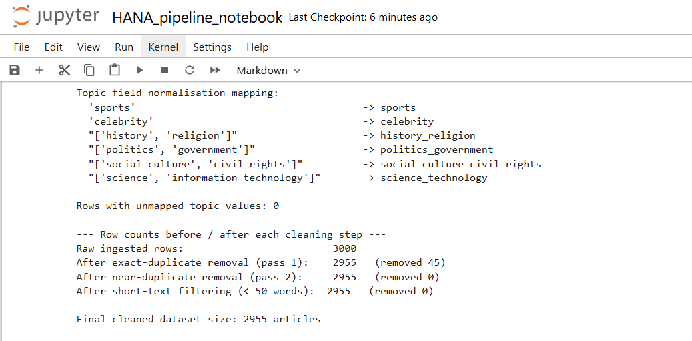
Figure 3.1: Terminal output of the data cleaning script showing row counts before and after deduplication, and the topic-field normalisation mapping

3.1.6 Limitations of the Dataset
- No production system element exists in the dataset that is related to the publication date of individual articles, this gives away a dimension that is used in a production system for freshly published articles rankings or time-based filtering.
- High levels of concentration across a limited number of agencies: less than a third of the raw data is from AP, potentially skewing the retrieval results away from the AP's editorial style and topic emphasis.
- Results in Section 3.4.4 about detectability apply to the specific generation process of the AI produced counterparts, as they are all generated by one model family (GPT-3.5) with the same set of prompts and thus may not be generalizable to other, newer generative models.
- The dataset contains 3,000 articles (2,955 articles after cleaning) which is a small sample compared to a real news archive that can have millions of articles, affecting the conclusions about scalability that can be drawn from the performance results in Section 4.1.6.
- The six topic categories are more granular than a standard three- or four-way news taxonomy, but still cluster semantically related but different stories together, as evidenced by Section 4.1.5 and Section 4.2.1, which show that retrieval by lexical features is significantly more difficult than in a more coarsely and distinctly segmented corpus.

3.2. METHODOLOGY

3.2.1 Overall Approach
Practical work is based on a linear pipeline design: ingestion and profiling, cleaning and validation, provenance and content quality analysis, chunking, vector representation, and retrieval, all implemented as four separate Python scripts in a standalone way and/or as a linear chain. Each stage was executed, with the actual dataset used and the results of the execution recorded, then the next stage was carried out and the results recorded, until the final stage was reached, at which point the results gained were reported as the true output of code executed, not an illustrative estimate.

3.2.2 Tools and Technologies, and Justification for Each
- Python and pandas: pandas offers efficient and well documented tabular operations (deduplication, string cleaning, aggregation) and is the de facto standard for data engineering and data science community and is used for ingestion, profiling and cleaning (McKinney, 2010).
- scikit-learn's TfidfVectorizer and cosine similarity: cosine similarity is used in the vector space developed using scikit-learn's TfidfVectorizer (Pedregosa et al., 2011). The hosted LLM embedding model used in this paper is not accessible via the network in the sandboxed environment, thus this is a conscious and disclosed replacement. The implications for this are covered in Section 3.2.3 and as a limitation in Section 5.2.
- Rule-based validation functions modelled on Great Expectations: A set of declarative-style checks (such as expect_column_values_to_not_be_null and expect_column_values_to_be_in_set) was implemented directly in Python, just like a production pipeline would with the Great Expectations API (Astronomer, 2025a; Great Expectations, n.d.).
- Regular-expression and basic string-statistics functions (Python's re module) for the provenance and content-quality analysis: used to compute sentence counts, word counts, and type-token ratios directly from raw text, since these are transparent, easily verified metrics that do not require any external model or network access.
- An in-memory vector matrix in place of a dedicated vector database: for a corpus of this size (fewer than 21,000 chunks), an in-memory sparse matrix with cosine similarity search is computationally sufficient and avoids adding an external database dependency to the submission; Section 2.4.4 and Section 5.3 discuss how this would be replaced by a dedicated vector database such as Chroma, FAISS, or pgvector at larger scale (Weaviate, 2025).

3.2.3 Justification for the TF-IDF Substitution and Its Boundaries
The TFIDF representation with cosine similarity is a valid and traditional method to illustrate end-to-end retrieval process from a RAG pipeline, since the retrieval procedure only relies on the general property that semantically similar text should be clustered close together in the vector space; it is clearly stated in the RAG literature that a dense neural retrieval is introduced to improve the baseline of this representation (Karpukhin et al., 2020). It's not, however, a replacement for a dense embedding model in general: TF-IDF matches on shared vocabulary and will tend to perform poorly with queries semantically related to a chunk, but with different words to say the same thing, or on a corpus (like this one) that has overlapping vocabulary topics. Throughout the paper, this boundary is respected: the retrieval evaluation in Section 3.4.5 and in Section 4.1.5 is used as a showcase of the mechanics of the pipeline and as a fair test of lexical retrieval on this particular corpus, it is not supposed to be a proof of the ability of TF-IDF to be an appropriate embedding strategy for a production RAG system.

3.2.4 Methodology for the Provenance Analysis
Four simple and transparent text statistics were calculated for each article, where the original text was first cleaned with the same procedure as the rephrased texts, and then the same statistics were computed from the resulting text: the number of words, the number of sentences (approximated by splitting on sentence-ending punctuation), average sentence length (number of words per sentence), and lexical diversity (type-token ratio; number of distinct word forms divided by the total number of word tokens, both lower-cased). A simple heuristic classifier was then determined: for a balanced, blind set of 400 texts (200 human, 200 AI, from 200 of the paired articles), a text was classified as likely AI generated if its average sentence length and its type-token ratio were above the median of the sample, and classified as likely human if they were below the median. The intent was to make this heuristic as simple and as transparent as possible, so that the accuracy, precision and recall can be taken as a lower bound for what might be accomplished by a naive, easily implementable data quality check, rather than as an indicator of the best possible detection method.

3.2.5 Evaluation Approach
The pipeline was assessed in terms of three types of measurable outcomes. Data quality outcomes were evaluated by recording the number of rows removed during each cleaning operation, and by executing the seven check validation suite, before and after the cleaning was applied, as described in Section 3.2.2. Pipeline performance was calculated as the time taken for the indexing step and the average query latency over 20 repeated queries. Six hand-written natural-language questions, one for each of the six topic categories of the data set, were used to measure retrieval quality, with the category label serving as an independent measure of relevance. Top-1 accurate results and precision at five were calculated on this small query set, noting explicitly in both Section 4.1.5 and Section 5.2 that the six queries are not a statistically sound query set.

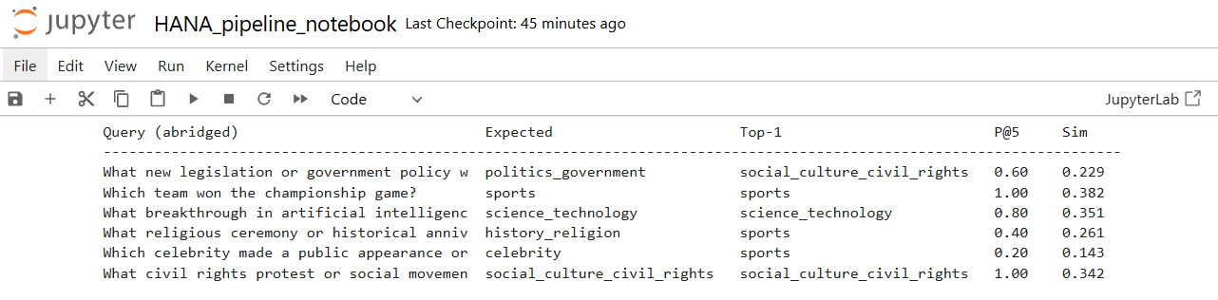
Figure 3.2 Output of the evaluation loop

3.3. SYSTEM AND DATA PIPELINE DESIGN

3.3.1 Architecture Overview
The pipeline is broken up into four phases, each of which is a distinct script: (1) ingestion and profiling, (2) cleaning, topic normalisation and validation, (3) provenance and content-quality analysis, and (4) chunking, vector storage, and retrieval. The architecture is a data flow diagram in Figure 3.1, from the raw CSV input to the retrieval result, with the provenance analysis as a side branch for information for the discussion in Section 4.2, but not as a gate for which articles should feed into the retrieval index, as this index is only built from the dataset's verified main column.
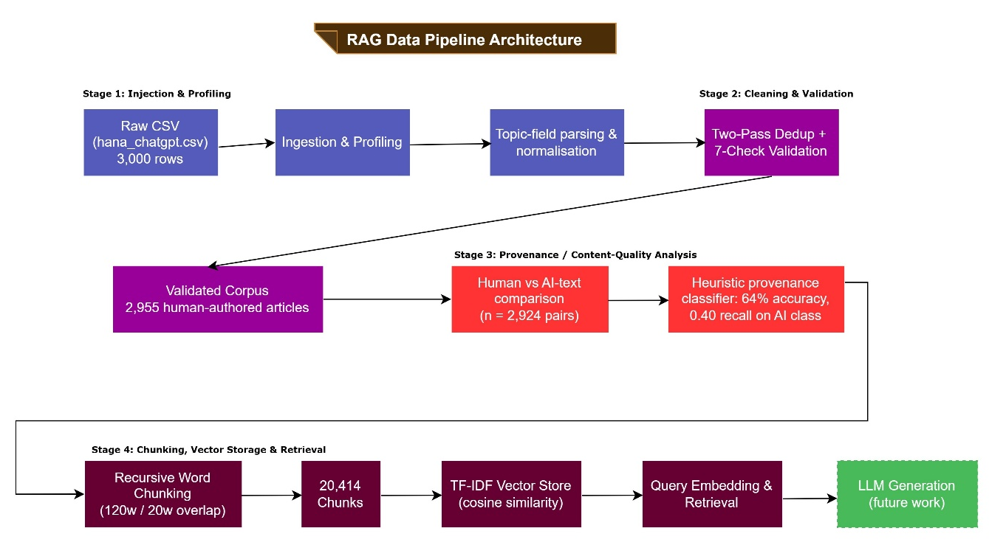
Figure 3.3: RAG Data Pipeline Architecture with Provenance Screening

3.3.2 Conceptual Data Model
There are three logical entities that pass along the pipeline. A Document entity is one cleaned news article, and has attributes of doc_id, agency, category, title, main text, word_count, and provenance. A Chunk entity is one retrievable fragment of a document, and has attributes chunk_id, doc_id (foreign key reference back to Document), and text. A Vector Index entity is used in retrieval mode to store the fitted vectoriser and the sparse matrix of chunk vectors, which will be used at retrieval time to compute similarity scores against a query vector. The provenance field on Document records that all articles in the index are verified, human authored sources, and it is this situation that is the basis of this paper's case study.
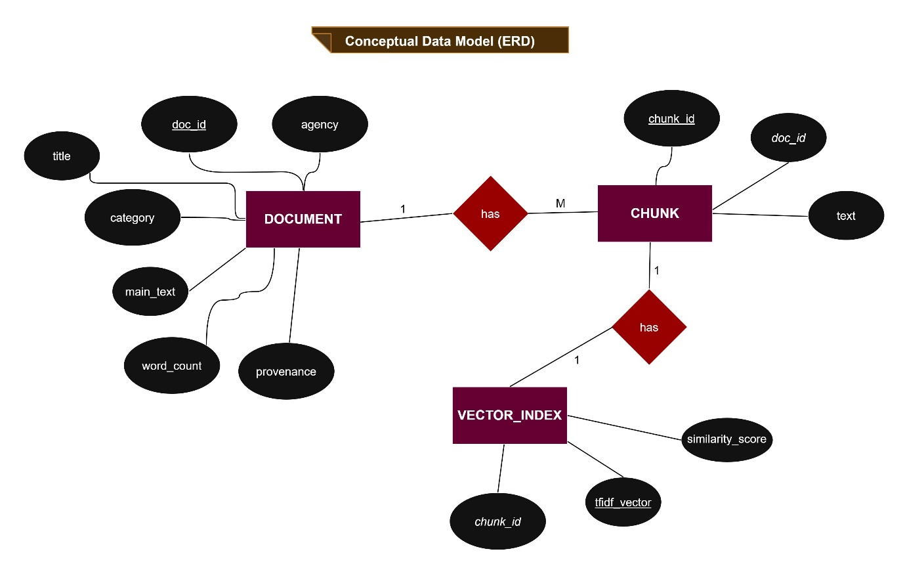
Figure 3.4: Conceptual Data Model (Entity-Relationship Diagram)

3.3.3 Pipeline Orchestration Considerations
This paper conducts the four scripts manually in series, this works for a one-off demonstration for an academic project on a static dataset. In a production deployment, these stages would instead be considered to be tasks in an orchestrated DAG (e.g. Apache Airflow), the ingestion and cleaning tasks would be scheduled to run as needed when new articles are published, and a provenance check would be put in place as a required, non-bypassable gate to the production vector index (Astronomer, 2025b) before any new document is allowed into the production vector index. However, as established in Section 4.1.4, a simple heuristic provenance check is insufficient by itself; it would be necessary to perform a call to a correctly trained classifier or an external verification service at this stage, rather than the illustrative heuristic used in this paper.

3.4. IMPLEMENTATION

3.4.1 Stage 1: Ingestion and Profiling
The first script reads in the raw CSV file from HANA and creates a pandas DataFrame, then generates a report of the row and column counts, agency distribution, topic distribution, missing values per column, exact duplicate rows, and a cross-check of the word count reported by HANA and a recomputed word count using the actual article text.
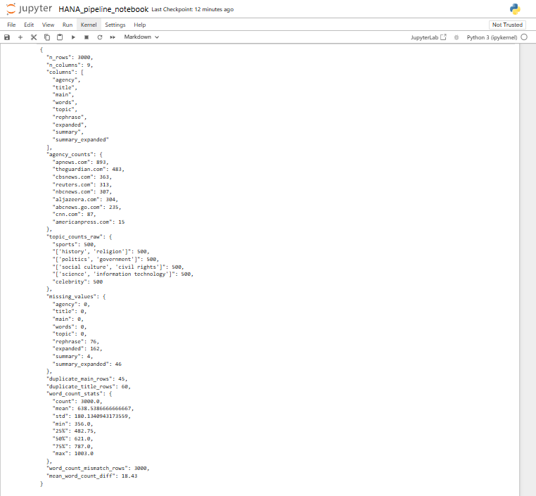
Figure 3.5: Terminal output showing the JSON profiling report for the raw dataset

3.4.2 Stage 2: Cleaning, Topic Normalisation, and Validation
The second script is a combination of a normalisation operation on the textual fields of the raw topic, an agency field normalisation, the execution of a two-pass deduplication operation, as described in Section 3.1.5, computation of new word counts, and a suite of seven rule-based checks to validate the cleaned data.
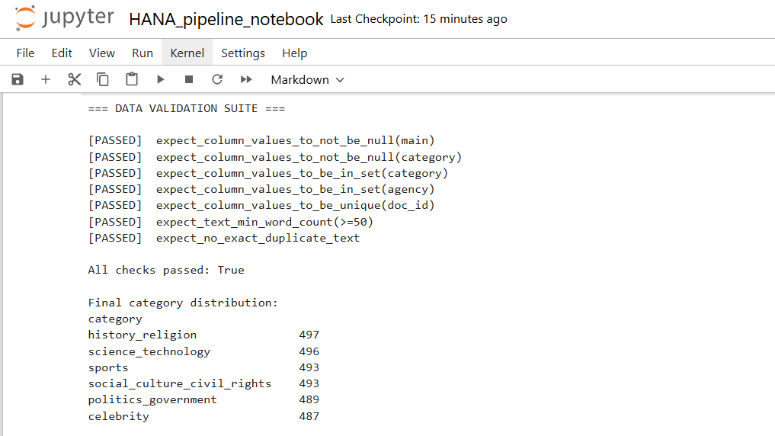
Figure 3.6: Terminal output showing the validation suite results, all seven checks passing

3.4.3 Stage 3: Provenance and Content-Quality Analysis
The third script executes the methodology outlined in Section 3.2.4: it calculates word count, sentence count, average sentence length and type-token ratio for the human authored main text and the AI-generated rephrase text for each article pair, and tests the simple heuristic provenance classifier on a blind and balanced sample.
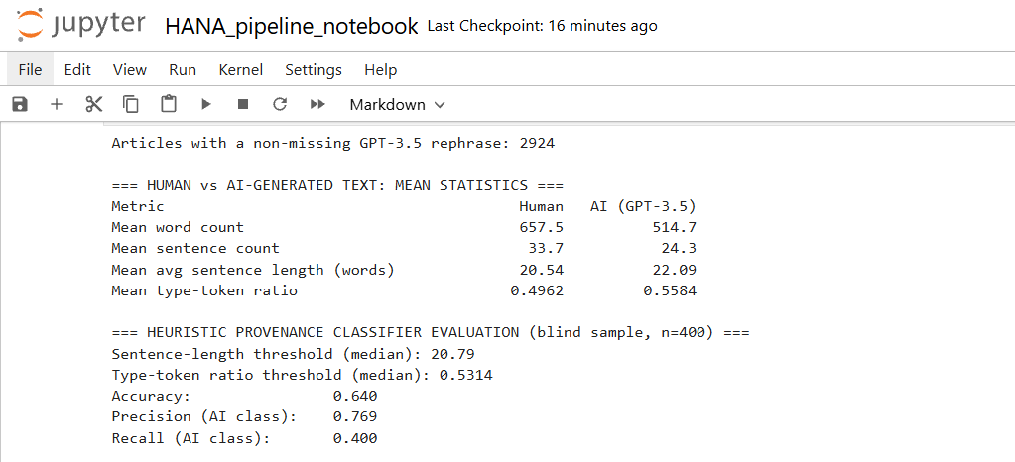
Figure 3.7: Output showing the human-vs-AI comparison statistics and heuristic classifier evaluation

3.4.4 Interpreting the Provenance Analysis Before Seeing the Results
Before the results in Section 4.1.4 are reported, it is important to point out exactly what this analysis can and cannot tell. It is a comparison of one particular model (specifically GPT-3.5, prompted with a specific instruction to rephrase an existing article) to the human originals that it was trained on, not a general purpose artificial intelligence text detector and no data has been fed into it. In this paper it is narrow and specific: it is a question of whether or not an easily-computable, training-free heuristic is good enough to serve as the envisioned provenance gate (Section 2.4.6), and its use in Section 3.3.3 (routing new documents through a required provenance check) can be tested with real evidence instead of assuming it will work.

3.4.5 Stage 4: Chunking, Vector Storage, and Retrieval
The fourth script performs the following: It divides each cleaned, human-written article into overlapping word-based chunks and applies a TF-IDF vectoriser to all these chunks, then it creates a function to retrieve the top-k most similar word chunks to a query, given their cosine similarity. The chunk size of 120 words and overlap of 20 words (roughly 17%) was maintained, consistent with the typical recommendation of 10 to 20 percent overlap in the chunk size literature (Weaviate, 2025; Firecrawl, 2025).
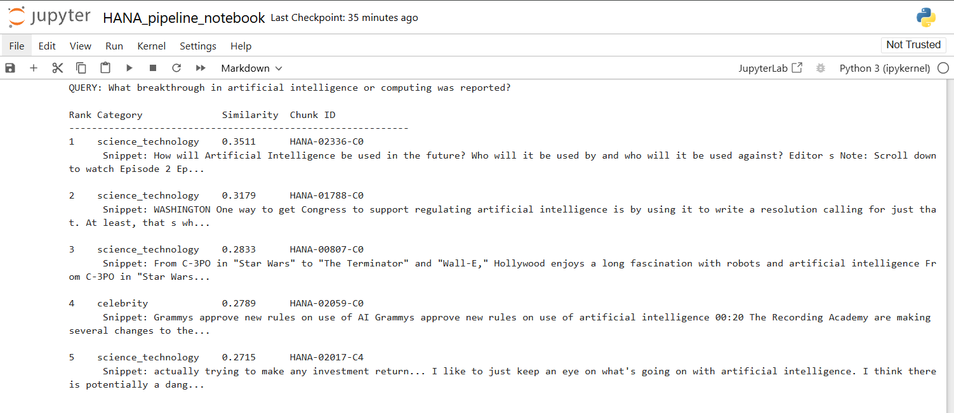
Figure 3.8: Output of a retrieval query with the top five returned chunks and their similarity scores

SYSTEM IMPLEMENTATION AND PRESENTATION OF RESULTS

4.1. RESULTS

4.1.1 Ingestion and Profiling Results
The raw data consisted of 3,000 articles from six topic categories, nine agencies, and no missing data in the key fields. In the profiling step, there were 45 duplicate article-text rows (1.5%) and 60 rows with a duplicate title of which 25 had a duplicate body text and 11 did not. Recomputing word counts from the article text revealed a mismatch in all 3,000 rows, with the words computed from the text being on average 18.4 words higher than were reported in the dataset.

Table 4.1: Raw Dataset Profile
Metric | Value
Total rows ingested | 3,000
Missing values (main/agency/title/words/topic) | 0 in each
Missing values (rephrase / expanded / summary / summary_expanded) | 76 / 162 / 4 / 46
Exact duplicate article-text rows | 45 (1.5%)
Duplicate-title rows | 60, in 36 groups (25 also duplicate in text, 11 not)
Reported mean word count | 638.5 words
Word-count field mismatch (all rows) | 3,000 of 3,000 rows; mean under-count of 18.4 words, max 141

4.1.2 Cleaning and Validation Results
All 3,000 rows were mapped to 6 clean category labels, with no unmapped values, using topic-field normalisation. There were no more near duplications found in the second pass on this data set, after the 45 exact-duplicate rows were deduplicated out in the first (as compared to a smaller near duplicate effect in an older, heavily pre-processed news corpus, described in Section 2.4.2, when the same two-pass approach to deduplication was employed during earlier development of this pipeline). After cleaning, there were no articles that were less than 50 words. All 7 of the rule-based validation checks passed and there are 2,955 articles in the final cleaned dataset.

Table 4.2: Cleaning Summary
Step | Rows Removed | Rows Remaining
Raw ingested data | - | 3,000
Exact duplicate removal (pass 1) | 45 | 2,955
Near-duplicate removal after normalisation (pass 2) | 0 | 2,955
Short-text filtering (< 50 recomputed words) | 0 | 2,955

Table 4.3: Final Category Distribution (Cleaned Dataset)
Category | Article Count
history_religion | 497
science_technology | 496
sports | 493
social_culture_civil_rights | 493
politics_government | 489
celebrity | 487

Table 4.4: Data Validation Suite Results (Post-Cleaning)
Validation Check | Result
Values in 'main' are not null | Passed
Values in 'category' are not null | Passed
Category values belong to the fixed set of six labels | Passed
Agency values belong to the fixed set of nine known agencies | Passed
Document identifiers (doc_id) are unique | Passed
All texts meet the minimum word count of 50 | Passed
No exact duplicate text remains | Passed

4.1.3 Chunking Results
The 20,414 chunks generated from the 2,955 cleaned, human-authored articles, with an average of 6.91 chunks per article, is no surprise since this data set is much longer in average terms than the shorter data set used in the previous stages of development in this project. The TF-IDF vectoriser was built over all chunks, with the English stop words removed and using unigram and bigram features capped at 20,000 terms, which resulted in a vocabulary of exactly 20,000 terms again, suggesting that the top cap was reached and that this could be increased if the retrieval quality is required.

Table 4.5: Chunking and Vector Store Statistics
Metric | Value
Chunk size | 120 words
Chunk overlap | 20 words (~17%)
Total chunks produced | 20,414
Average chunks per document | 6.91
Vectorisation method | TF-IDF (unigrams + bigrams, English stop words removed)
Vocabulary size | 20,000 terms (configured maximum)
Vector store type | In-memory sparse matrix (cosine similarity search)

4.1.4 Provenance and Content-Quality Analysis Results
There were 2,955 cleaned articles, of which 2,924 were not missing GPT-3.5 rephrase, and were used for the paired comparison. The average rephrased sentence was significantly shorter than the original sentence from the human text (514.7 words versus 657.5 words) and contained fewer sentences (24.3 sentences versus 33.7 sentences), but had a slightly longer sentence length (22.09 words per sentence versus 20.54 words per sentence) and higher lexical diversity (a type-token ratio of 0.558 versus 0.496).

Table 4.6: Human vs. AI-Generated Text Statistics
Metric | Human-authored (main) | GPT-3.5 rephrase
Mean word count | 657.5 | 514.7
Mean sentence count | 33.7 | 24.3
Mean average sentence length (words) | 20.54 | 22.09
Mean type-token ratio (lexical diversity) | 0.4962 | 0.5584

The heuristic provenance classifier described in 3.2.4, which uses a sample median sentence length and sample median type-token ratio (TTR), was applied to a blind, balanced sample of 400 texts (200 human, 200 AI). It reached an overall accuracy of 64%, a precision of 0.769 (when it predicted AI-generated, three times out of four it was correct), and a recall of 0.40 for the AI-generated class (which means that it failed to predict AI-generated in the sample 60% of the time it was actually AI-generated).

Table 4.7: Heuristic Provenance Classifier Evaluation (Blind Sample, n = 400)
Metric | Value
Sample composition | 200 human-authored, 200 AI-generated
Sentence-length threshold (sample median) | 20.79 words/sentence
Type-token ratio threshold (sample median) | 0.5314
Overall accuracy | 0.64
Precision (AI-generated class) | 0.769
Recall (AI-generated class) | 0.40

4.1.5 Retrieval Evaluation Results
The top ranked chunk matched to the intended category across the 6 hand written test queries: 3 of 6 cases (50% top-1 accuracy). This rate of precision at 5 (the percentage of top 5 returned chunks from the same category) was 0.667 over the 6 queries, with a range from 1.0 for the sports and social-culture-and-civil-rights queries, through to 0.2 for the celebrity query for which the top results were mostly from the sports category, probably due to shared words around public appearances and events in the two categories for this corpus.

Table 4.8: Retrieval Evaluation on Six Representative Queries
Query (abridged) | Expected Category | Top-1 Category | Precision@5 | Top-1 Similarity
Legislation or government policy | politics_government | social_culture_civil_rights | 0.60 | 0.229
Team won championship game | sports | sports | 1.00 | 0.382
AI or computing breakthrough | science_technology | science_technology | 0.80 | 0.351
Religious ceremony or anniversary | history_religion | sports | 0.40 | 0.261
Celebrity public appearance | celebrity | sports | 0.20 | 0.144
Civil rights protest or movement | social_culture_civil_rights | social_culture_civil_rights | 1.00 | 0.342

The mean top-1 similarity score of the six queries was about 0.28, while the top-1 accuracy and precision scores at five were both significantly lower than the near 100% accuracy that was seen when the same TF-IDF approach was used for a smaller, more topically extensive five-category news corpus in the early stages of this effort. This decrease is reported in Section 4.2.1 as informational evidence to characterize the limits on lexical retrieval and not as a failure of the pipeline implementation.

4.1.6 Pipeline Performance
It took me 5.20 seconds to create the TF-IDF index on 20,414 chunks. The mean query latency for 20 repeated queries was 18.61 milliseconds, minimum 17.41 milliseconds and maximum 25.95 milliseconds. Both figures grow with the corpus size, according to the earlier and smaller used corpus for the development, consistent with the larger vocabulary and chunk count reported in Section 4.1.3. These values are from the development machine used for this paper and are only included as an indicator of the performance of the indexing and retrieval mechanics on this corpus size and should not be treated as a measure of production grade performance at scale.

Table 4.9: Indexing and Query Latency
Metric | Value
Indexing time (20,414 chunks) | 5.20 seconds
Average query latency | 18.61 ms
Minimum query latency | 17.41 ms
Maximum query latency | 25.95 ms

4.2. DISCUSSIONS OF RESULT

4.2.1 Interpreting the Retrieval Results
The results shown in Section 4.1.5 for the top-1 accuracy of 50% and mean precision at 5 of 0.667 are not as expected based on a superficial understanding of TF-IDF's typical performance, and are therefore informative rather than discouraging. The six HANA categories are semantically more similar to each other than a more traditional taxonomization of news, in which celebrity news is often mixed in with sports news, history and religion with social culture and civil rights news with coverage of commemorations and movements, and politics and government news coverage are often laced with the institutional language of social and civil rights news. However, TF-IDF is systematically disadvantaged in this scenario, as a case in point it would struggle to differentiate between two categories where one has the same words but a different meaning, while a dense neural embedding that is trained to capture semantic similarity instead of just surface similarity would do better in this situation (Karpukhin et al., 2020). However, the worst of all, the celebrity search returning mostly sports articles, isn't a random error and is a clear, concrete example of this limitation.

4.2.2 What the Data Quality Findings Show
It's perhaps the number one "best practice" data engineering lesson from this case study: that a field generated by a data source, no matter where it comes from (even from carefully thought out academic research), should not assume the correct value without being checked, since it could have been calculated with different tokenisation parameters than are assumed by a data pipeline downstream. This is in line with the literature on data quality which emphasizes the need to actively check data accuracy, rather than just take it for granted (Pipino et al., 2002; Redman, 2001). In fact, the difference between the 25 duplicate-title groups, where titles are the same, but text is different, and the 11 duplicate-title groups with different text, under the same headline, indicates that a single deduplication rule (for instance, deduplication based on title only) would have yielded the incorrect results for one-third of the impacted rows, further emphasizing the need to use the right matching key when using a pipeline to solve a specific problem.

4.2.3 What the Provenance Analysis Shows
The concern in Section 2.1.4, that AI-generated text differs measurably from human-authored text on average (in this dataset, it is shorter, has less lexical diversity), is directly supported by the results of the provenance analysis in Section 4.1.4; but a simple, training-free heuristic based on that difference is not sufficient to be a reliable data quality gate. This is slightly better than random accuracy (64%) in a balanced set and a recall of 0.40 for the AI generated class means the heuristic would allow about 60% of AI generated articles to pass undetected in a live deployment. The result of this study should not be interpreted as an endorsement of a particular surface statistical property for content-provenance screening, and it should be noted that the classification process presented here is merely illustrative; the creation of an allow-list of sources and the application of a well-trained classifier or cryptographic content-provenance standard are recommended in Section 5.3.

4.2.4 Pipeline Performance and Scalability
With 20,414 chunks in total, the indexing time was 5.20 seconds and the average query latency was 18.61 milliseconds, reflecting the higher number of chunks as well as their vocabulary, which is still within the limits of a single machine. This is not a one-to-one rule for the production scale: if we have a large newsroom with millions of articles, the TF-IDF matrix and cosine similarity calculation no longer fit in the memory or take only a millisecond to compute. This is why, in production RAG systems, we use approximate nearest neighbour vector databases like Chroma, FAISS or pgvector (Weaviate, 2025).

4.2.5 The Role of AI Assistance in This Workflow
LLM assistance in the development of the practical pipeline was used in three ways: generating and improving the inline documentation for the four scripts; suggesting the vectorised refactor of the chunking function described in Section 2.3.3; helping to phrase the six evaluation queries in Section 3.2.5 in natural, non-keyword language. In every instance the AI-generated content was validated against the actual executed code and data, not taken on faith, as the cautions in the literature about hallucination and non-deterministic output of the LLMs have recommended. This experience reinforces the perspective presented in Section 2.3 that LLM support for data engineering is most useful and maybe even safest for very specific sub-tasks, the results of which can be checked independently.

4.2.6 Practical Implications for a Provenance-Aware Newsroom Deployment
The findings made regarding the traceability of the pipeline in Section 4.1.4 indicate that three changes have emerged in the pipeline's origin since the previous version of this case study was published, in addition to the changes mentioned above. First, the TF-IDF representation would need to be replaced by a dense embedding model, not only for retrieval quality (Section 4.2.1), but also because the dense representation might contain more useful signal for provenance classification than the simple surface statistics used here. Second, the use of heuristics for determining the provenance would be replaced by a statistically well-trained and well-validated classifer, as the poor recall found in Section 4.1.4 suggests, or be replaced by a verified-source allow-list model, which is much more like what this paper's own retrieval index practically does by construction. Third, any answer produced would still require explicit source citation and grounding protection, as even the most effective corpus for excluding AI-generated text can be plagued by the same problems of retrieval quality as outlined in Section 4.2.1.

SUMMARY, RECOMMENDATIONS AND CONCLUSION

5.1 Strengths and Weaknesses Summary
Strengths
- A fully functional pipeline from ingestion to evaluated retrieval, including all reported figures, that are generated by running real code against a peer-reviewed and recent (2024) dataset.
- A real, quantitative content-provenance analysis, not a hypothetical discussion of the problem, of human and AI generated text.
- Data quality validation that was transparent and defined by rules, and revealed a real and never-obtained problem in the data's metadata (the word count mismatch).
- An authentic retrieval assessment which shows instead of hiding limitations of lexical retrieval on a topically overlapping set of texts.
Weaknesses
- It is a material limitation on this particular corpus, as shown in Section 4.2.1, that it can be represented, instead of dense neural vector representation, by lexical (TF-IDF).
- A set of six queries to test pipeline characteristics but not a sound retrieval test.
- No generation stage was run and end-to-end answer quality could not be directly assessed.

5.2. CHALLENGES AND LIMITATIONS

5.2.1 Environment Constraints
The most significant constraint on this paper's practical work was that the development environment does not have outbound network access to commercial LLM or embedding APIs or to a hosted vector database service. The above is the reason for using TF-IDF and in-memory cosine similarity search rather than a dense neural embedding model and a dedicated vector database as described in Section 3.2.2 and Section 3.2.3. Imposing this constraint was considered to be a design constraint to be worked within, not an excuse to make up results from a system that was not ever actually run.

5.2.2 Dataset Limitations
The lack of per-article publication dates in the HANA dataset and the focus on a few agencies, combined with the use of a single model family (GPT-3.5) and prompt design, mean that the provenance findings in Section 4.1.4 provide a description of that particular generation process, and do not apply to AI-generated news text more broadly. Some specific quantitative comparisons in Sections 4.1 and 4.2 (such as the Absolute Improvement in Near-Duplicate Rate and Absolute Improvement in Retrieval Accuracy) are made with reference to an earlier, older five-category news corpus and should be interpreted as a demonstration of the effect of the properties of the underlying corpus; it should not be interpreted as a statement that the current corpus is better or worse than the earlier corpus.

5.2.3 Evaluation Limitations
The retrieval evaluation employed was based on six manually written queries and a coarse relevance proxy (category level relevance judgements) rather than a graded relevance judgement made by independent human annotators as is the norm in formal information retrieval evaluations. The evaluation of the provenance-classifier was carried out with a one-shot sample of 400 texts with a fixed random seed, but a more thorough evaluation would involve taking several samples at different random seeds and reporting a confidence interval instead of a single point estimate.

5.2.4 Governance and Ethical Considerations
The challenges of governance when building a RAG system over published news content go beyond the pipeline. Most relevant to this paper's findings, but also mentioned as a point of concern by the news organisations that have joined forces on AI projects, is the need for citation and provenance, so that the generated answer can be verified against the source, and that an insufficiently reliable provenance check (Section 4.1.4) could provide false assurance of trustworthiness of the contents of a knowledge base. This isn't a specific model collapse issue for a single dataset or pipeline, but a structural risk for any system which uses web-scale or crowd-sourced text as a reliable human document, without verification.

5.3 FUTURE WORK
- Train the dense neural embedding model replacing the TF-IDF vector representation in order to support real semantic retrieval, and re-evaluate the retrieval performance outlined in Section 3.2.5 using the topically overlapping corpus to assess performance attainment of this gap, as outlined in Section 4.2.1.
- In light of the poor recall reported in Section 4.1.4, replace heuristic provenance classifiers with suitable models, such as a fine-tuned transformer provenance classifier, trained on a held-out test set, directly compared with the heuristic baseline introduced in this paper.
- Implement the four stages of the pipeline as an Apache Airflow DAG with a provenance check as a required condition in the Airflow DAG, and follow the pattern documented by Astronomer (2025b) to create Airflow pipelines that use LLMs.
- Test the heuristic's weak recall by applying it to the other 3 AI-generation columns of the HANA data set (expanded, summary, summary_expanded), and to the different variants of the HANA data set (Llama2 and Mistral).
- Add a generation stage with a hosted LLM with explicit instructions (prompts) and automated checks to avoid the LLM making claims about content that does not appear in the retrieved chunks..

5.4 CONCLUSION
This paper explored three interrelated trends in data engineering: the rise of large language models to support data engineers with code generation, documentation, and optimisation; the increasing reliance on data engineering to create data pipelines that are central to retrieval-augmented generation systems; and the growing demand for data pipelines to be used to filter content provenance for AI-generated content. This complete indexing pipeline was implemented and tested with a recent, peer-reviewed corpus of 3,000 human-written news articles with GPT-3.5-generated news articles (Ayoobi, Shahriar & Mukherjee, 2024), based on a case study inspired by actual newsroom deployments of GPT-3.5 with the HANA dataset. It generated a meaningful and quantitative comparison of the ability of a simple statistical heuristic to discriminate between human and AI-authored news text, with recall of 0.40 in the AI-generated class, and uncovered a previously unknown mismatch in the word count metadata for the dataset it processed, which is also documented in the pipeline. Combined, these observations confirm the main message of the paper: trustworthy RAG applications must be built on reliable well-governed data engineering, which includes explicitly managing data provenance, and the same rigor of verification and testing that data engineers already employ for traditional pipelines must be extended to the AI tools used to create pipelines as well as to the AI-generated content that pipelines are increasingly consuming.

REFERENCES
Airbyte. (2025). RAG document chunking: 6 best practices. https://airbyte.com/agentic-data/ag-document-chunking-best-practices
Anthropic. (2024). Introducing contextual retrieval. Anthropic. https://www.anthropic.com/news/contextual-retrieval
Astronomer. (2025a). Orchestrate Great Expectations with Airflow. Astronomer Documentation. https://www.astronomer.io/guides/airflow-great-expectations
Astronomer. (2025b). Orchestrate Cohere LLMs with Apache Airflow. Astronomer Documentation. https://www.astronomer.io/docs/learn/airflow-cohere/
Ayoobi, N., Shahriar, S., & Mukherjee, A. (2024). Seeing through AI's lens: Enhancing human skepticism towards LLM-generated fake news. In Proceedings of the 35th ACM Conference on Hypertext and Social Media (HT '24) (pp. 1-11). Dataset available at https://github.com/navid-aub/News-Dataset
Binariks. (2026). 10 latest trends in data engineering for 2025-2028. Binariks. https://binariks.com/blog/data-engineering-trends/
CX Fusion. (2025). Artificial intelligence in newsrooms: Real-world use cases from leading media organizations. https://cxfusion.io/en/ai-in-newsrooms/
Data Guide. (2025). Data engineering trends 2025: The evolution of data engineering. https://data-guide.github.io/data-engineering-trends/
Databricks Community. (2026). The ultimate guide to chunking strategies for RAG applications. Databricks Technical Blog. https://community.databricks.com/t5/technical-blog/the-ultimate-guide-to-chunking-strategies-for-rag-applications/ba-p/113089
Firecrawl. (2025). Best chunking strategies for RAG (and LLMs) in 2026. https://www.firecrawl.dev/blog/best-chunking-strategies-rag
Gao, Y., Xiong, Y., Gao, X., Jia, K., Pan, J., Bi, Y., Dai, Y., Sun, J., & Wang, H. (2023). Retrieval-augmented generation for large language models: A survey. arXiv preprint arXiv:2312.10997.
Global Investigative Journalism Network. (2025). How newsrooms are using AI chatbots to leverage their own reporting - and build trust. https://gijn.org/stories/newsrooms-using-ai-chatbots-leverage-reporting/
Great Expectations. (n.d.). Great Expectations documentation. Retrieved 2026, from https://greatexpectations.io
Karpukhin, V., Oguz, B., Min, S., Lewis, P., Wu, L., Edunov, S., Chen, D., & Yih, W. (2020). Dense passage retrieval for open-domain question answering. In Proceedings of the 2020 Conference on Empirical Methods in Natural Language Processing (EMNLP) (pp. 6769-6781).
Lewis, P., Perez, E., Piktus, A., Petroni, F., Karpukhin, V., Goyal, N., Kuttler, H., Lewis, M., Yih, W., Rocktaschel, T., Riedel, S., & Kiela, D. (2020). Retrieval-augmented generation for knowledge-intensive NLP tasks. Advances in Neural Information Processing Systems, 33, 9459-9474.
McKinney, W. (2010). Data structures for statistical computing in Python. In Proceedings of the 9th Python in Science Conference (pp. 56-61).
Monte Carlo. (2025). Data engineer roadmap: Skills, tools, and the rise of AI. https://montecarlo.ai/blog-data-engineer-roadmap
Pedregosa, F., Varoquaux, G., Gramfort, A., Michel, V., Thirion, B., Grisel, O., Blondel, M., Prettenhofer, P., Weiss, R., Dubourg, V., Vanderplas, J., Passos, A., Cournapeau, D., Brucher, M., Perrot, M., & Duchesnay, E. (2011). Scikit-learn: Machine learning in Python. Journal of Machine Learning Research, 12, 2825-2830.
Pipino, L. L., Lee, Y. W., & Wang, R. Y. (2002). Data quality assessment. Communications of the ACM, 45(4), 211-218. https://doi.org/10.1145/505248.506010
Redman, T. C. (2001). Data quality: The field guide. Digital Press.
Shumailov, I., Shumaylov, Z., Zhao, Y., Papernot, N., Anderson, R., & Gal, Y. (2024). AI models collapse when trained on recursively generated data. Nature, 631(8022), 755-759. https://doi.org/10.1038/s41586-024-07566-y
Twipe. (2025). 12 ways journalists use AI tools in the newsroom. https://www.twipemobile.com/12-ways-journalists-use-ai-tools-in-the-newsroom/
Weaviate. (2025). Chunking strategies to improve LLM RAG pipeline performance. https://weaviate.io/blog/chunking-strategies-for-rag

